

Concept-to-Mastery Bridge: A Proposed Intelligent Learning Management System with a Visual AI Support Layer
Mmesoma Judith Ezeobi¹*, Tovia Iyeoma Akoh-Ali¹, Irabor David Aire¹, Muhammad Jitari Idriss¹, Joseph Brang Solomon¹, Ahmad-Nazir Oluwasubomi Abdulazeez¹, Nuru Halima Murtala¹, and Johnwendy C.N.¹
¹Department of Computer Science, Faculty of Natural and Applied Sciences, Nile University of Nigeria, Abuja, Nigeria
*Corresponding Author: Mmesoma Judith Ezeobi (e-mail: [email address])
ABSTRACT:
KEYWORDS: learning management system, formative feedback, misconception diagnosis, learning analytics, retrieval-augmented generation, visual explanation, Visual AI.
I. INTRODUCTION
The Learning Management System (LMS) has become the central infrastructure of technology-enhanced education. Platforms such as Moodle were designed to organise course content, assessment, and communication within a single environment (Dougiamas & Taylor, 2003). The core functions of registration, course management, assignment submission, marking, and result release are mature and widely deployed. The weaker link is what happens after marking: a student usually receives a score and general comments, and must decide alone what to study next.
Feedback research shows why this matters. Hattie and Timperley (2007) describe feedback as most useful when it tells learners where they are going, how they are going, and where to go next. A later meta-analysis of 435 studies found a medium average effect of feedback on learning (d = 0.48), with large variation that depended on the information the feedback carried (Wisniewski et al., 2020). The quality of feedback, not simply its presence, determines its value.
Introductory programming illustrates the difficulty. Reviews of novice programming report difficulties that span syntax, concepts, and problem-solving strategy, often linked to missing prior knowledge (Qian & Lehman, 2017). A student who loses marks on a recursion exercise may be unable to trace nested calls, may not see the base case, or may lack the prerequisite that a function returns a value to its caller. The same wrong answer can have several causes, so a mark alone cannot tell them apart.
Current assessment workflows therefore show that a student answered incorrectly, but they do not systematically investigate why, connect the cause to the lecturer's own reading materials, check that understanding has improved, or summarise concept-level patterns for the lecturer. Grades alone do not identify the missing concept or prerequisite, general feedback may give no next step, and lecturers have little concept-level visibility of recurring class-wide difficulty. These are hypotheses to be tested locally rather than established facts about every LMS or student.
The study is guided by three research questions:
- RQ1. How can an LMS help students identify the possible underlying reasons for their difficulties with specific concepts once marked results are released?
- RQ2. How can lecturer-provided reading materials be connected to diagnostic evidence so that students receive targeted, source-traceable support?
- RQ3. How can a follow-up verification step and aggregated class-level evidence show students and lecturers whether support helped, and can a visual presentation layer make this easier to use?
The aim of the project is to design, prototype, and evaluate an LMS enhancement centred on the Concept-to-Mastery Bridge (CMB) that helps students identify possible reasons for learning difficulties, receive targeted support from lecturer-approved materials, and demonstrate whether their understanding has improved. The aim is pursued through three specific objectives:
- To investigate existing LMS capabilities (Google Classroom and Microsoft Teams) and research on feedback, misconceptions, and adaptive support, and to gather requirements from students and lecturers.
- To design the CMB diagnose, support, and verify cycle, its integration with lecturer materials, the role-based student and lecturer experiences, and a complementary Visual AI presentation layer.
- To implement an end-to-end prototype of the core CMB cycle for one subject area (introductory Python) and evaluate its access control, recommendation relevance, usability, and preliminary learning change without claiming causation.
Formative assessment uses evidence of performance to close the gap between current and desired understanding (Black & Wiliam, 1998). In programming education, Qian and Lehman (2017) review misconceptions and other difficulties, and a later design-based study found that feedback targeted at common errors and their underlying misconceptions helped students correct their code (Qian & Lehman, 2019). That study concerned error feedback inside an automated assessment system and not links to a lecturer's own notes. Keuning et al. (2018) systematically reviewed how tools generate automated feedback on programming exercises.
Intelligent tutoring research reports that step-based computer tutoring approached the effect of human tutoring in the studies reviewed (VanLehn, 2011), and a meta-analysis with college students reported moderate positive effects while noting that systems were generally less effective than human tutoring (Steenbergen-Hu & Cooper, 2014). Knowledge tracing estimates skill mastery from response sequences (Corbett & Anderson, 1995; Pelánek, 2017) but typically needs substantial response data, which an undergraduate pilot will lack. Retrieval-augmented generation combines a language model with retrieval from a defined document collection (Lewis et al., 2020), which makes it plausible to ground support in a lecturer's own notes, although lecturer review remains necessary because inaccurate output is reduced but not removed.
Google Classroom and Microsoft Teams already provide assignments, feedback, materials, and analytics, and both have introduced adaptive or AI-assisted practice features. Table I summarises what the sources reviewed describe. These are vendor and training pages that change frequently, so each row must be verified hands-on before the defence.
TABLE I: Existing Platform Capabilities (to Be Verified Hands-On)
Platform | Relevant capabilities in sources reviewed | Not found in sources reviewed
Google Classroom | Assignments and feedback; practice sets with auto-grading, real-time feedback, adaptive skill identification, hints and resources; teacher insights on concepts needing more time (NSW Department of Education, n.d.) | A release-gated post-marking diagnostic dialogue linked to passages of the lecturer's uploaded notes, with fresh-item verification
Microsoft Teams for Education | Assignments, grading and feedback; Learning Accelerators such as Reading Progress and Math Progress; AI-generated passages and questions; Insights dashboards (Microsoft, n.d.-a; Microsoft, n.d.-b) | Same as above; the accelerators found target skills such as reading fluency, not post-marking concept diagnosis for arbitrary course content
Intelligent tutoring and knowledge tracing | Step-level feedback and mastery estimation (VanLehn, 2011; Corbett & Anderson, 1995) | Integration with an LMS marking and release lifecycle and with a lecturer's own uploaded materials varies

The sources reviewed describe practice, hints, analytics, and AI-generated questions, but not a release-gated cycle that moves from marked results to cause investigation, lecturer-material recommendation, and verification with a new task. Whether this gap exists in practice, or in undocumented features, is a testable question for the requirements study. Originality is not claimed. The proposed design combines established techniques into one workflow, and Table II compares standard practice with the proposed contribution.
TABLE II: Value-Add Comparison (Standard Practice vs. Proposed Design)
Functional Area | Standard / Existing Practice | Proposed Contribution (Value-Add)
Post-marking feedback | Score and general comments shown to the student | Concept-to-Mastery Bridge opens after the lecturer releases results and guides the student through a learning-repair cycle
Cause investigation | Left to the student | Two to four short diagnostic items per flagged concept, with candidate explanations, confidence levels, and an explicit unclear outcome
Reading materials | Notes available in a course folder | Recommendations point to specific lecturer-approved passages with the source shown, or state that none was found
Verification | Student judges own improvement | A new question tests whether the concept can be applied; lecturer-set thresholds decide the next step
Lecturer view | Marks and individual submissions | Aggregated concept-level summary with small-group suppression, shown visually
Access and AI use | Not applicable | Server-side role and release checks; AI output optional, labelled, and reviewable

The proposal adds two features to a standard LMS foundation, deliberately unequal in importance. The primary feature is the Concept-to-Mastery Bridge. After the lecturer marks and releases results, the student can choose Explore My Learning Gaps. CMB then detects concepts linked to lost marks, asks short diagnostic questions that separate candidate causes, maps findings to lecturer-reviewed concepts and prerequisites, recommends sections of the lecturer's own materials and practice, verifies learning with a new question, adapts the next step, and reports aggregated evidence to the lecturer. It states uncertainty, never treats one wrong answer as proof, and offers Ask my lecturer throughout.
The complementary feature is Visual AI, a role-aware presentation layer that renders CMB output as concept maps, step-by-step visual walkthroughs, and progress views for students, and as a concept heat-map for lecturers. It does not diagnose or decide access. It is interpreted here as diagrams and guided visual assistance only, and it excludes facial recognition, webcam monitoring, and emotion detection; this interpretation requires supervisor confirmation. The system is a proposal: no prototype is claimed and evaluation is planned rather than completed.
II. SYSTEM ARCHITECTURE
The proposed system is a web-based LMS with three layers and a strict dependency direction. The LMS foundation provides accounts, roles, courses, enrolment, materials, assignments, marking, feedback, result release, and records. The Concept-to-Mastery Bridge runs on that foundation as the primary learning-support feature, and Visual AI sits on top and presents what the other layers produce. Three roles are supported. Students view courses and materials, submit work, see released results, and use CMB when available. Lecturers create courses and assignments, upload and tag materials, maintain the concept map, mark, release results, review AI-generated content, and read class-level summaries. Administrators approve lecturer accounts, manage users, and can disable AI features. Roles are assigned and checked on the server, and lecturer accounts stay inactive until approved.
One design rule governs the architecture: deterministic code decides access, release status, and permissions, and AI never does. AI may help word explanations or draft practice items from approved passages, always labelled and reviewable by the lecturer. The study follows an iterative, design-based approach, building a small slice, testing it with a few real users, and refining it.
Figure 1 shows the architecture. Users reach the system through role-specific browser interfaces. Every request passes through the application server and its authentication and access-control module before any other module is called. The server reads from and writes to the relational database and file storage, and the only path to an external AI provider is the AI Gateway.
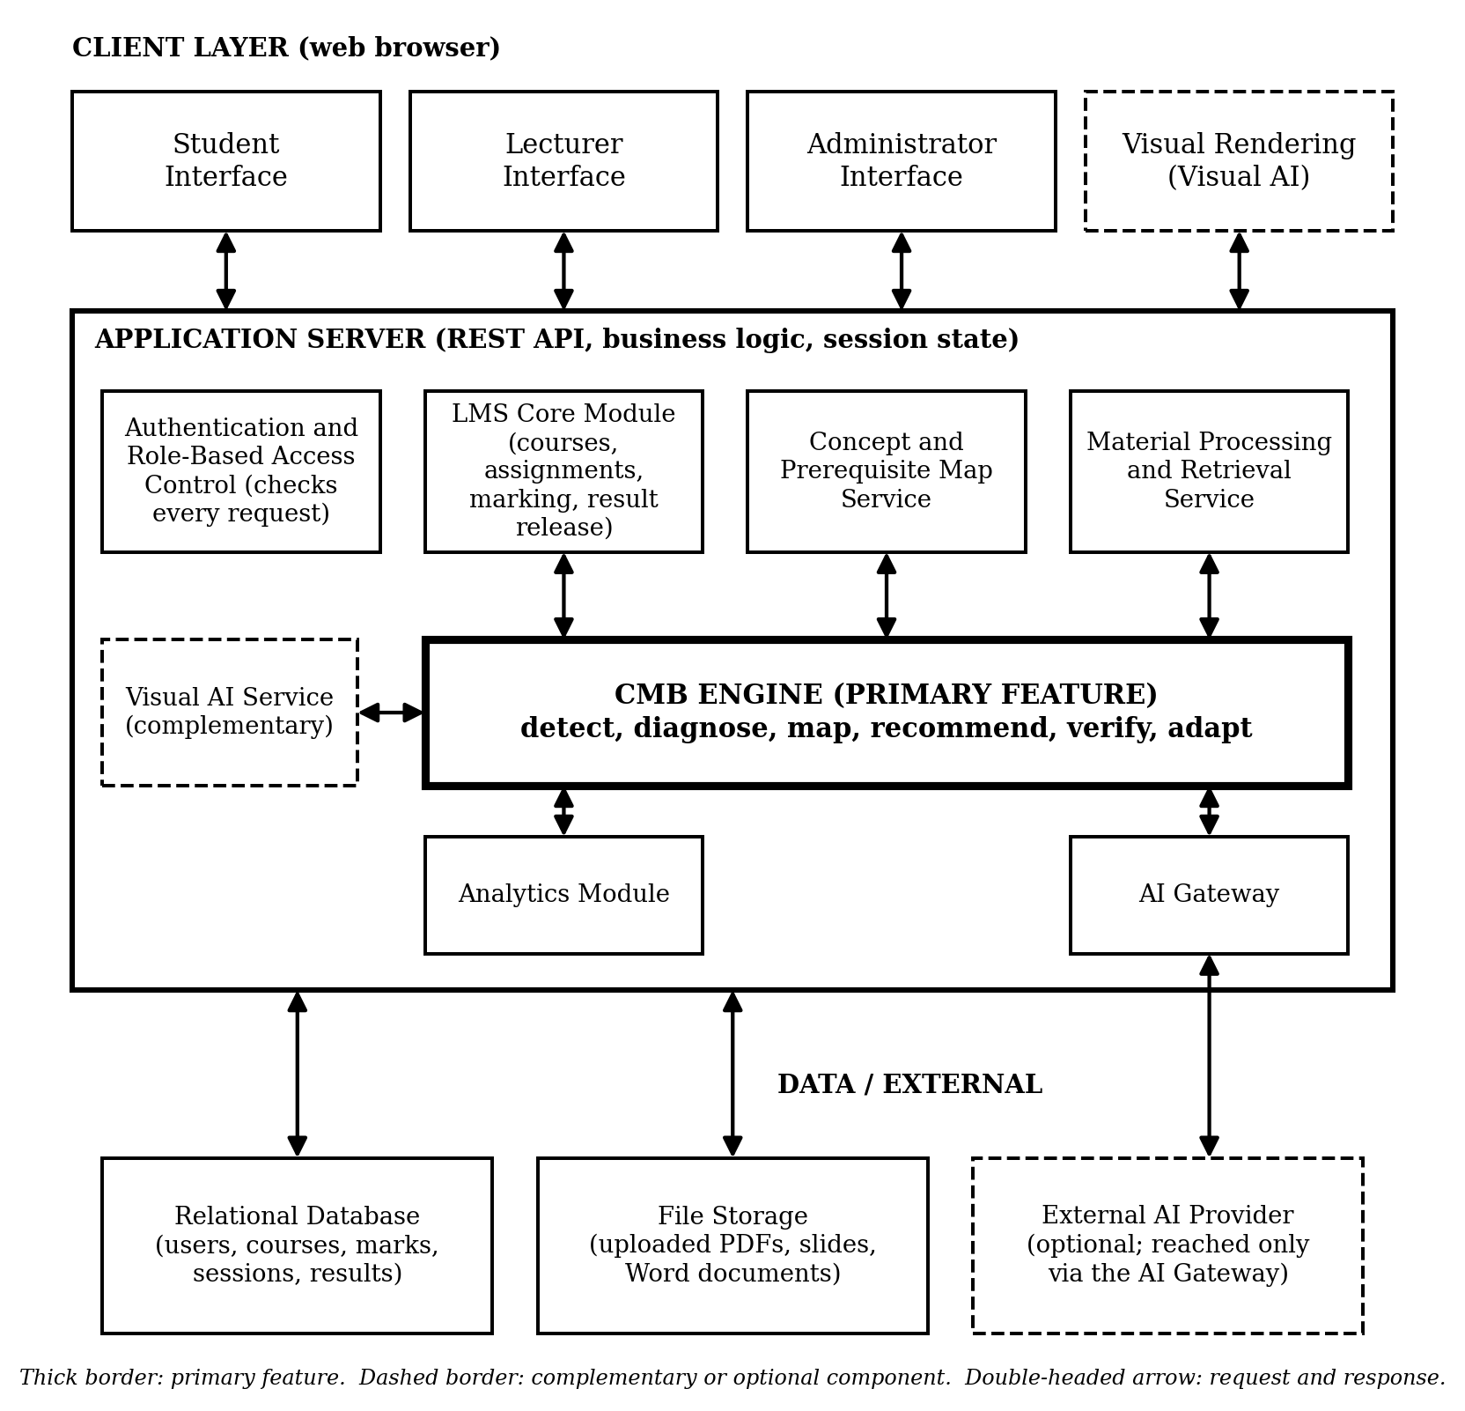
Figure 1: Proposed system architecture (CMB is the primary feature).
Table III explains what each component does and what data it receives and returns.
TABLE III: Component Responsibilities and Data
Component | What it does | Data in | Data out
Student, Lecturer, and Administrator interfaces | Role-specific dashboards for viewing courses, submitting work, marking, releasing, reviewing, and managing users | User actions | Requests; rendered pages
Visual Rendering (Visual AI) | Draws concept maps, call-stack walkthroughs, progress paths, and the lecturer heat-map, each with a text alternative | Structured visual data | Visuals; user feedback
Authentication and Role-Based Access Control | Registers users, assigns roles on the server, approves lecturers, and checks permission on every request | Credentials, role, session | Allow or deny
LMS Core Module | Courses, enrolment, assignments, submissions, marks, feedback, and release status; holds the rule deciding whether CMB is available | Lecturer and student actions | Marks, release status, CMB eligibility
Concept and Prerequisite Map Service | Stores lecturer-approved concepts and prerequisite links, rejects cycles, maps questions and material sections to concepts | Lecturer-authored concepts | Concept graph
Material Processing and Retrieval Service | Extracts text from PDF, PowerPoint, and Word files, splits it into sections, indexes it, and retrieves passages for a diagnosed concept | Uploaded files, tags, concept | Source passages with page or slide
CMB Engine (primary) | Runs the learning-repair cycle as a state machine: detect, diagnose, map, recommend, verify, adapt; rules and lecturer data first, AI only assists wording | Marks, concept map, responses, passages | Explanations with confidence, interventions, outcomes
Visual AI Service (complementary) | Builds the structured data behind each visual after the same permission checks | CMB outcomes, concept graph | Visual data, text alternatives
Analytics Module | Aggregates outcomes per concept and hides groups below a minimum size | CMB records | Class-level summaries
AI Gateway | The only exit to an external AI provider; applies source-only prompts, logs what is sent, enforces timeouts, and can be switched off per course | Approved passages, prompts | Draft wording or items for review
Database and file storage | Store users, roles, courses, marks, sessions, explanations, results, and uploaded lecturer files | Module writes, uploads | Records, files

The user flow is shown in Figure 2. The lecturer registers and is approved by an administrator, creates the course, uploads and tags materials, sets the concept map, creates assignments with learning objectives, and later marks submissions and releases results. The student registers, reads materials (optionally using the reading companion), submits the assignment, and views the results once they are released. Only then can the student open Explore My Learning Gaps, work through diagnostic items, read the recommended lecturer passages, practise, attempt a fresh verification question, and receive a next step or the option to ask the lecturer. Before release, the interface explains why the feature is unavailable. The lecturer reviews the aggregated concept summary and can correct AI-generated content.
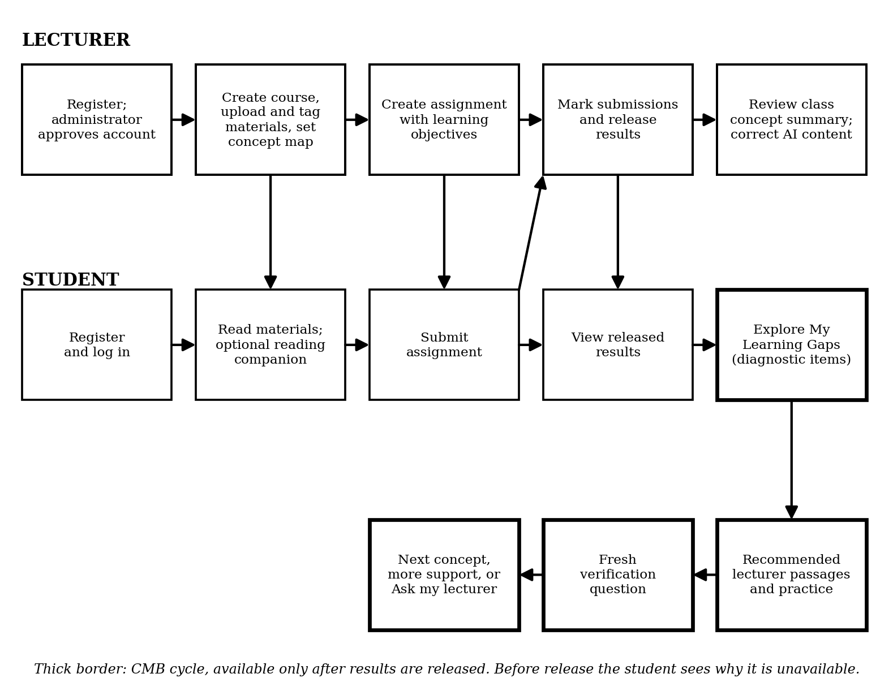
Figure 2: User flow for lecturers and students (CMB steps in thick borders).
The data flow is shown in Figure 3 and runs from marked results to lecturer evidence in ten steps:
- The lecturer saves marks and comments and releases results; the LMS Core Module records the release status and time.
- The server checks six conditions: the student is enrolled, has submitted, the work is marked, results are released, CMB is enabled for the assignment, and the caller is a student. Any failure is refused with a plain explanation, and the check is repeated on every CMB request.
- The student starts a session and the CMB Engine creates a diagnostic session linked to the submission.
- The engine detects flagged concepts from question scores and the question-to-concept mapping, with lecturer comments adding hints where available.
- The student answers two to four short diagnostic items per concept; responses, time, and confidence choice are stored.
- Rules over the responses and the prerequisite graph produce candidate explanations with confidence levels, or an unclear result when answers do not discriminate.
- The retrieval service returns lecturer-approved passages and practice items with their source, or reports that none exist; the AI Gateway may reword approved text.
- A new verification item, never the original question, tests whether the concept can be applied.
- Lecturer-set thresholds choose the next step and the outcome is stored.
- The analytics module aggregates outcomes per concept, and the Visual AI service turns the student's own results into concept maps and progress views and the class aggregates into the lecturer heat-map.
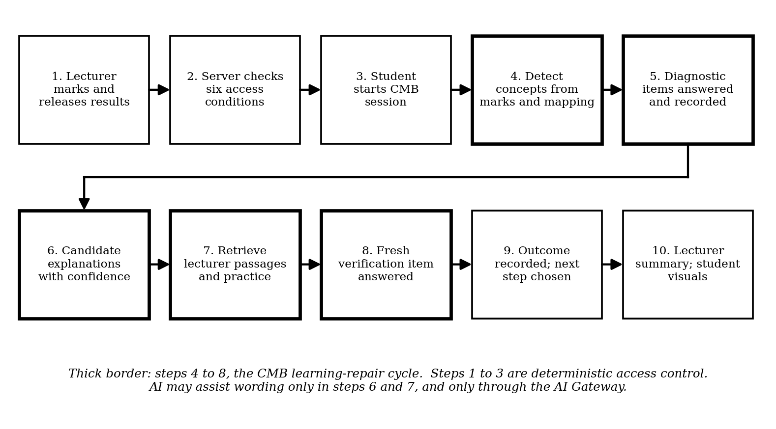
Figure 3: Data flow from marked results to lecturer evidence.
A separate reading companion lets students run ungraded self-checks before results are released; it never reads marks and writes no diagnostic records unless the student opts in.
The relational schema separates identity, course content, assessment, and learning-support records. Table IV lists the principal tables. Student-level rows are readable only by that student and by lecturers of the owning course, with access logged, and lecturer analytics use aggregates only.
TABLE IV: Principal Database Tables
Table | Key Fields | Purpose
users / role_assignments | user_id (PK), email, password_hash, status; role, approved_by | Identity and role-based access
courses / enrolments | course_id (PK), title, owner_user_id (FK); user_id (FK), course_id (FK) | Course catalogue and membership
concepts / concept_prereqs | concept_id (PK), course_id (FK), name; concept_id (FK), prereq_concept_id (FK) | Lecturer-approved concept graph
materials / material_sections | material_id (PK), file_path; section_id (PK), material_id (FK), text, page_or_slide | Uploaded files and citable passages
assignments / questions | assignment_id (PK), due_at, release_status, cmb_enabled; question_id (PK), max_score | Deadlines, release rule, concept-mapped questions
submissions / marks | submission_id (PK), user_id (FK), marking_status; submission_id (FK), question_id (FK), score | Student work and lecturer marks
diagnostic_sessions / responses | session_id (PK), submission_id (FK); item_id (FK), answer, confidence_choice | Diagnostic evidence per attempt
candidate_explanations | id (PK), session_id (FK), concept_id (FK), label, confidence | Hypotheses, never stored as facts
interventions / recommended_resources | id (PK), explanation_id (FK); section_id (FK), reason | Targeted support and its sources
followup_results | id (PK), intervention_id (FK), bank_item_id (FK), correct | Verification outcomes
access_log | id (PK), user_id (FK), action, target, at | Audit trail of record access and release events

Technology selection was guided by three criteria: open-source availability, suitability for an undergraduate team, and coverage of every component in Table III. Django was preferred over FastAPI with React or Node.js with React because it provides authentication, permissions, and administration out of the box. Table V gives the proposed stack, which is subject to confirmation by the group.
TABLE V: Technology Selection and Rationale
Layer | Technology | Rationale
Frontend | React with a JavaScript diagram library (for example Mermaid or D3) | Component-based role interfaces; browser-side rendering of concept maps and heat-maps
Backend | Python with Django and Django REST Framework | Built-in authentication, permissions, and admin; Python suits the pilot subject and document-processing libraries
Database | PostgreSQL | Relational model fits users, courses, marks, and sessions; full-text search for retrieval; optional vector extension
File storage | Server disk or S3-compatible object storage | Keeps lecturer uploads separate from the database
Document processing | Python libraries for PDF, PowerPoint, and Word text extraction; OCR only if needed | Extracts text for sectioning and indexing; scanned files may fail and are reported
Retrieval | PostgreSQL full-text search with lecturer tags; embedding search as an optional addition | Hybrid retrieval is more robust than either alone; tags give lecturers control
AI integration | Hosted language-model API behind the AI Gateway | Optional, switchable, and logged; the core cycle works without it
Testing and deployment | pytest, automated accessibility checks, Docker | Repeatable tests for access control and release rules; consistent deployment

REFERENCES
Black, P., & Wiliam, D. (1998). Assessment and classroom learning. Assessment in Education: Principles, Policy & Practice, 5(1), 7–74. https://doi.org/10.1080/0969595980050102
Corbett, A. T., & Anderson, J. R. (1995). Knowledge tracing: Modeling the acquisition of procedural knowledge. User Modeling and User-Adapted Interaction, 4(4), 253–278. https://doi.org/10.1007/BF01099821
Dougiamas, M., & Taylor, P. C. (2003). Moodle: Using learning communities to create an open source course management system. In Proceedings of EDMEDIA 2003: World Conference on Educational Multimedia, Hypermedia and Telecommunications (pp. 171–178). Association for the Advancement of Computing in Education.
Hattie, J., & Timperley, H. (2007). The power of feedback. Review of Educational Research, 77(1), 81–112. https://doi.org/10.3102/003465430298487
Keuning, H., Jeuring, J., & Heeren, B. (2018). A systematic literature review of automated feedback generation for programming exercises. ACM Transactions on Computing Education, 19(1), Article 3. https://doi.org/10.1145/3231711
Lewis, P., Perez, E., Piktus, A., Petroni, F., Karpukhin, V., Goyal, N., Küttler, H., Lewis, M., Yih, W., Rocktäschel, T., Riedel, S., & Kiela, D. (2020). Retrieval-augmented generation for knowledge-intensive NLP tasks. Advances in Neural Information Processing Systems, 33. https://doi.org/10.48550/arXiv.2005.11401
Microsoft. (n.d.-a). Overview the benefits of Teams Assignments [Training module]. Microsoft Learn. https://learn.microsoft.com/en-us/training/modules/use-microsoft-teams-assignments-learning-management-systems/overview-benefits-teams-assignments
Microsoft. (n.d.-b). Reading Progress. Microsoft Learn Educator Center. https://learn.microsoft.com/training/educator-center/product-guides/reading-progress
NSW Department of Education. (n.d.). Google Classroom: Practice sets and video activities [Video transcript]. Technology 4 Learning. https://t4l.schools.nsw.gov.au/resources/professional-learning-resources/google-resources/google-classroom0/transcript-googleclassroompracticesetsvideoactivities.html
Pelánek, R. (2017). Bayesian knowledge tracing, logistic models, and beyond: An overview of learner modeling techniques. User Modeling and User-Adapted Interaction, 27(3–5), 313–350. https://doi.org/10.1007/s11257-017-9193-2
Qian, Y., & Lehman, J. (2017). Students' misconceptions and other difficulties in introductory programming: A literature review. ACM Transactions on Computing Education, 18(1), Article 1. https://doi.org/10.1145/3077618
Qian, Y., & Lehman, J. D. (2019). Using targeted feedback to address common student misconceptions in introductory programming: A data-driven approach. SAGE Open, 9(4). https://doi.org/10.1177/2158244019885136
Steenbergen-Hu, S., & Cooper, H. (2014). A meta-analysis of the effectiveness of intelligent tutoring systems on college students' academic learning. Journal of Educational Psychology, 106(2), 331–347. https://doi.org/10.1037/a0034752
VanLehn, K. (2011). The relative effectiveness of human tutoring, intelligent tutoring systems, and other tutoring systems. Educational Psychologist, 46(4), 197–221. https://doi.org/10.1080/00461520.2011.611369
Wisniewski, B., Zierer, K., & Hattie, J. (2020). The power of feedback revisited: A meta-analysis of educational feedback research. Frontiers in Psychology, 10, Article 3087. https://doi.org/10.3389/fpsyg.2019.03087

